Installation Step (Skip this step)
mkdir kobuki_ws
cd kobuki_ws/
mkdir src
cd src
sudo apt install git
git clone https://github.com/kobuki-base/kobuki_ros.git
git clone https://github.com/kobuki-base/kobuki_ros_interfaces.git

References
https://github.com/kobuki-base/kobuki_ros
https://github.com/kobuki-base

Testing Step
ros2 launch kobuki_node kobuki_node-launch.py
ros2 run kobuki_keyop kobuki_keyop_node --ros-args -r motor_power:=/commands/motor_power cmd_vel:=/commands/velocity
ros2 topic echo /button

Command Line:
ros2 topic pub /commands/velocity geometry_msgs/msg/Twist "{linear: {x: 0.1, y: 0.0, z: 0.0}, angular: {x: 0.0, y: 0.0, z: 0.1}}"

Install Realsense Camera (Skip this step)

sudo apt-get install ros-humble-realsense2-camera
sudo apt-get install ros-humble-realsense2-description
sudo apt-get install librealsense2-dkms
sudo apt-key adv --keyserver keyserver.ubuntu.com --recv-key F6E65AC044F831AC80A06380C8B3A55A6F3EFCDE || sudo apt-key adv --keyserver hkp://keyserver.ubuntu.com:80 --recv-key F6E65AC044F831AC80A06380C8B3A55A6F3EFCDE
sudo apt-get update
sudo apt-get install ros-humble-usb-cam
ros2 launch realsense2_camera rs_launch.py enable_pointcloud:=true device_type:=d435
ros2 launch realsense2_camera rs_launch.py enable_pointcloud:=true device_type:=d435 initial_reset:=true enable_sync:=true --debug
sudo apt-get install ros-humble-librealsense2
colcon build
source ./install/setup.bash
ros2 launch realsense2_camera rs_launch.py device_type:=d435 initial_reset:=true --debug
sudo apt-get install ros-humble-image-view
ros2 run image_view image_view image:=/camera/color/image_raw
or
cd src
git clone https://github.com/IntelRealSense/realsense-ros.git
git checkout

Install RPLidar (Skip this step)
cd asha_ws
cd src
git clone -b ros2 https://github.com/slamtec/rplidar_ros.git
cd ..
colcon build --symlink-install
source ./install/setup.bash
ros2 launch rplidar_ros view_rplidar_a3_launch.py

References:

https://index.ros.org/repos/page/2/time/
https://index.ros.org/r/usb_cam/
https://github.com/allenh1/rplidar_ros
https://index.ros.org/r/realsense2_camera/
https://github.com/IntelRealSense/librealsense
https://github.com/IntelRealSense/librealsense/blob/master/doc/distribution_linux.md
https://github.com/klintan/ros2_usb_camera
https://github.com/Slamtec/rplidar_ros/tree/ros2

Remotely control Kobuki laptop
1. Open Visual Studio

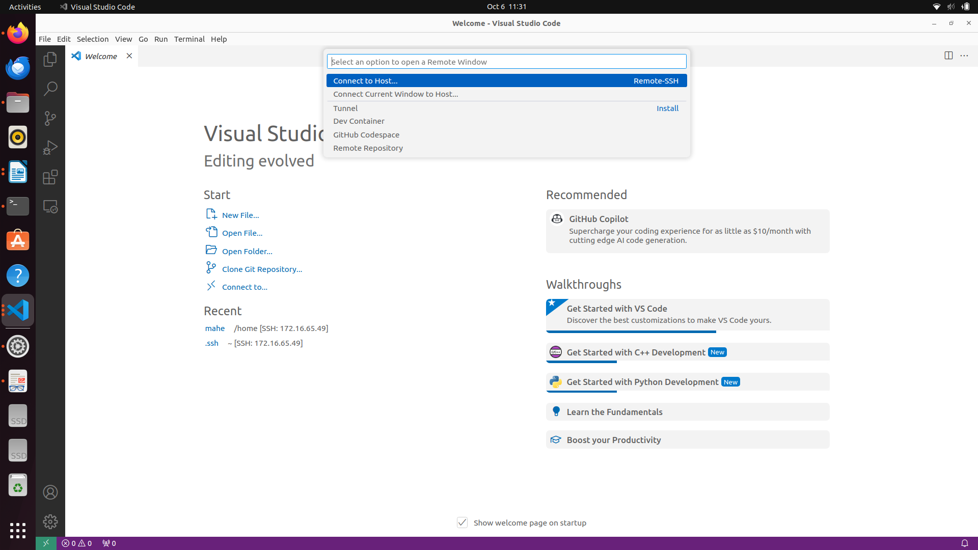
2. Connect to host
Click on <>
or add new host
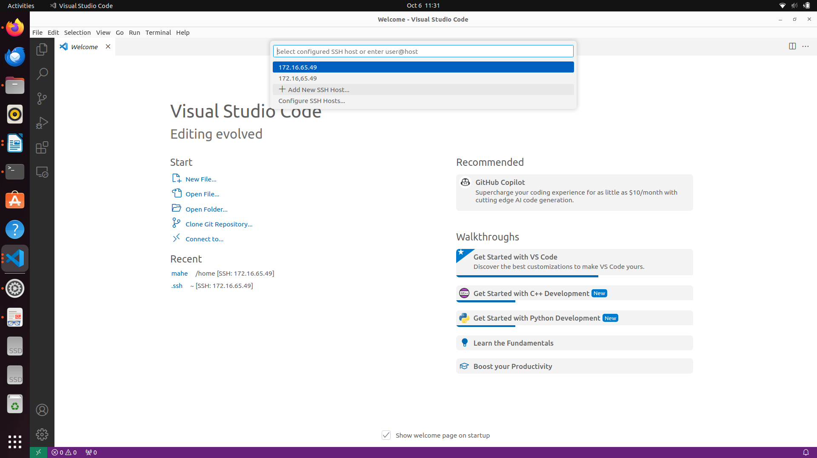
3. type
ssh mahe@172.16.65.49
(mahe refers to name of the laptop connected too turtlebot)
(ip address is obtained as
type ifconfig
find the IP address

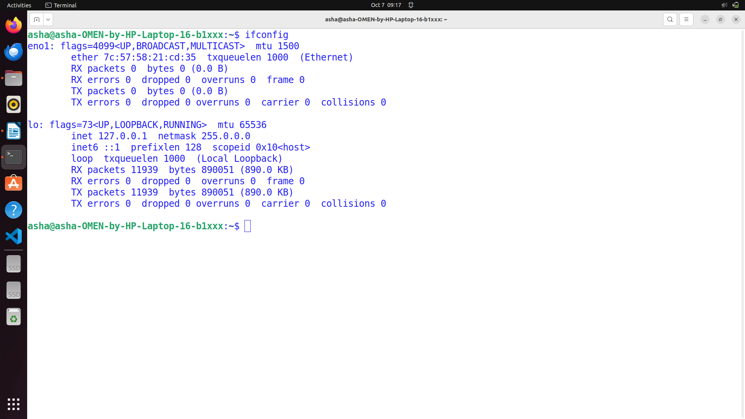
Address to note down

4. enter password (robolab)

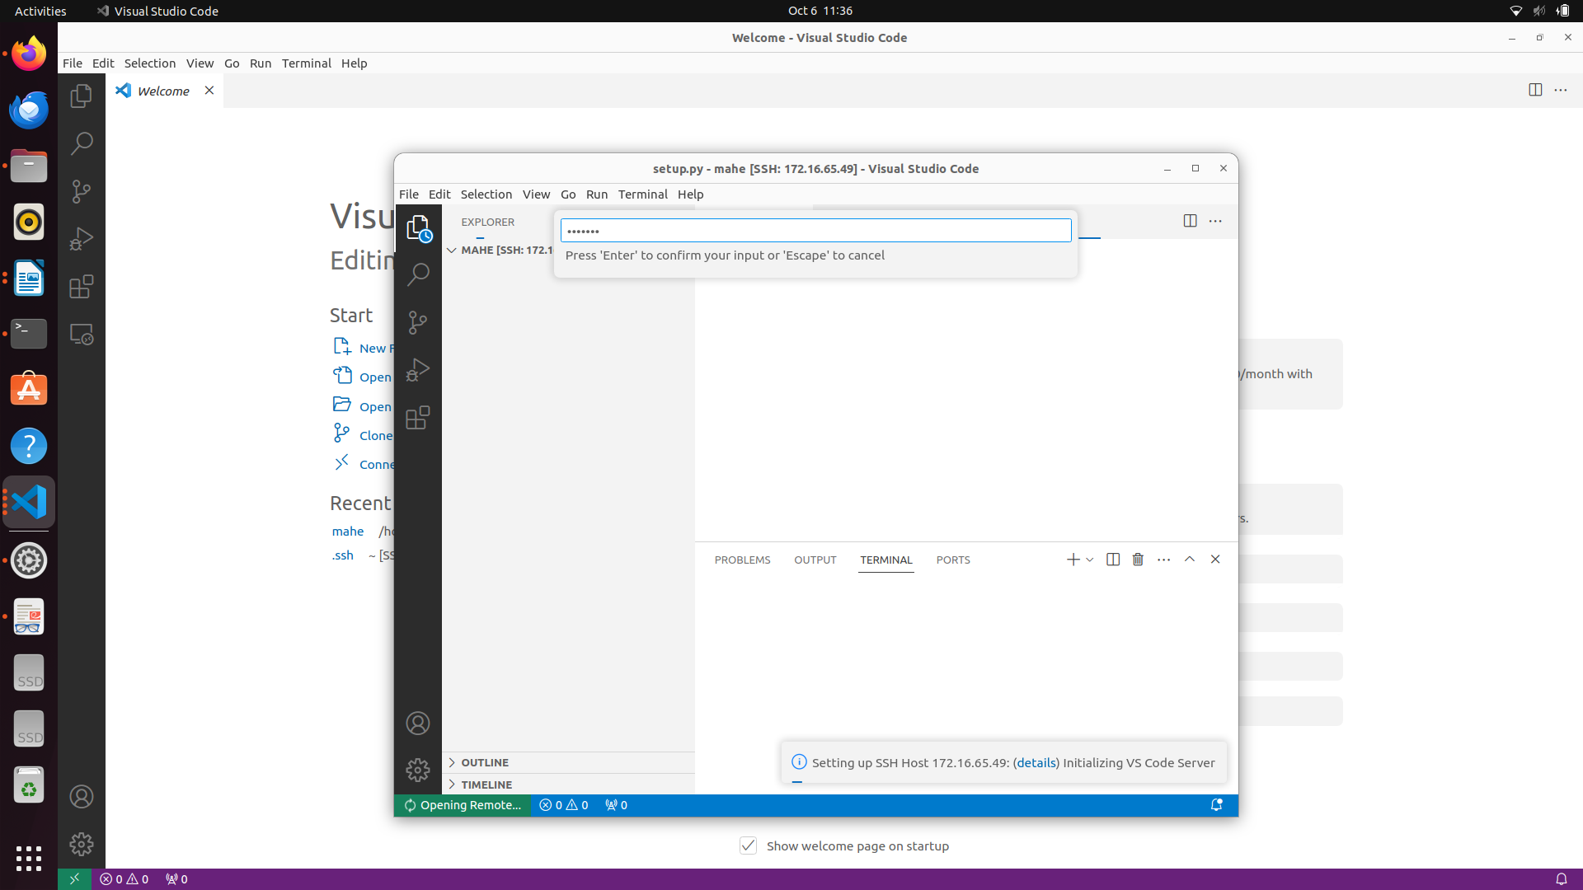
File → Open new folder
select workspace

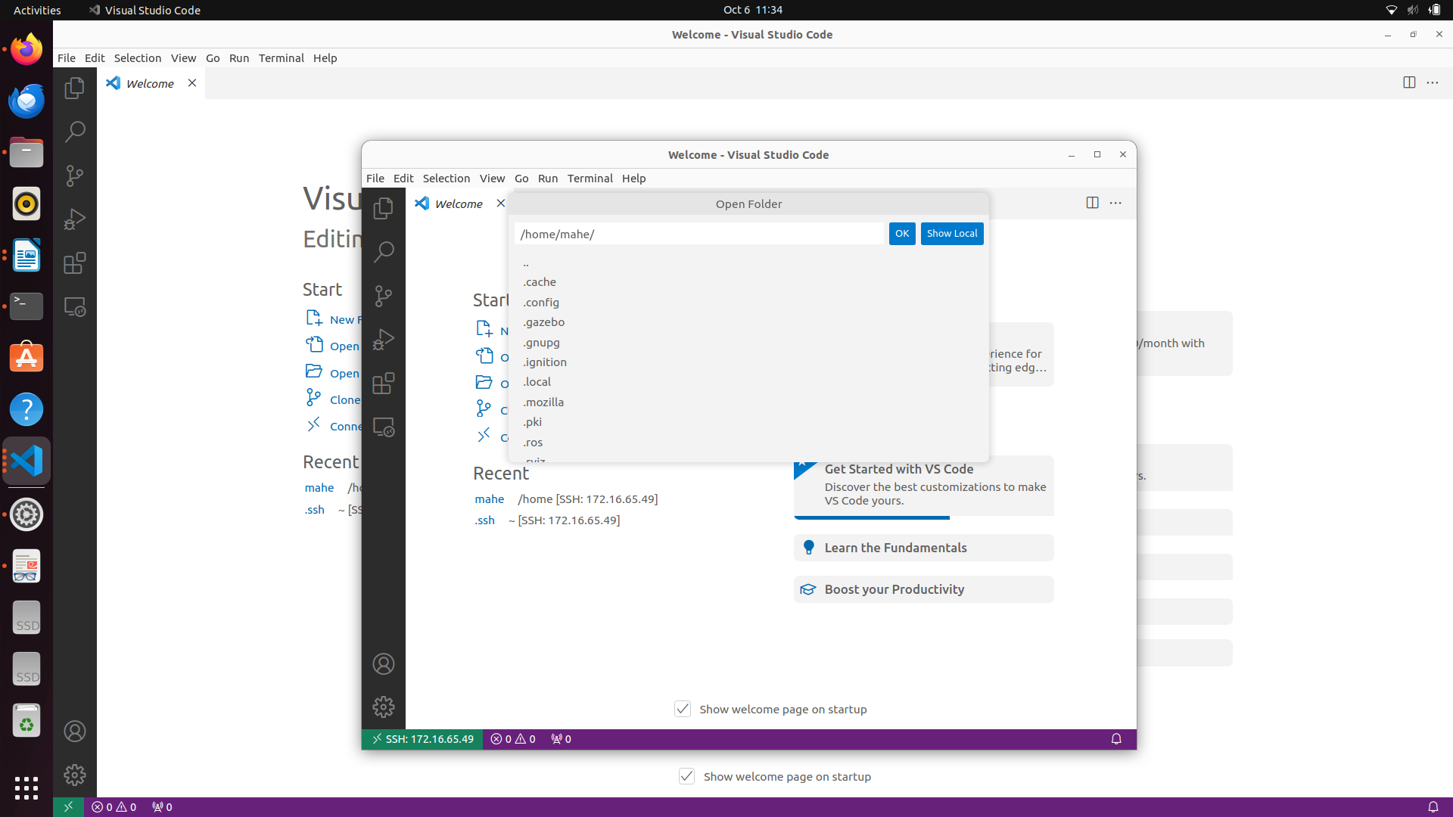

create workspace in the home folder
mkdir -p kobuki_ws/src
cd kobuki_ws/src
ros2 pkg create --build-type ament_python turtlebot_pkg --dependencies rclpy
cd ..
colcon build

open kobuki_ws/src/turtlebot_pkg folder in visual studio
create new file
name it as goforward

type the following code

#!/usr/bin/env python3
import rclpy
from rclpy.node import Node
from geometry_msgs.msg import Twist

class GoForward(Node):
def __init__(self):
super().__init__('GoForward')
self.get_logger().info("To stop, press ctrl + c")
self.publisher_ = self.create_publisher(Twist, 'commands/velocity', 10)
self.timer_ = self.create_timer(0.5, self.timer_callback)

def timer_callback(self):
msg = Twist()
msg.linear.x = 0.1
msg.angular.z = 0.0
self.publisher_.publish(msg)

def main(args=None):
rclpy.init()
node = GoForward()
rclpy.spin(node)
rclpy.shutdown()

if __name__ == '__main__':
main()

from setuptools import setup
package_name = 'turtlebot_pkg'

setup(
name=package_name,
version='0.0.0',
packages=[package_name],
data_files=[
('share/ament_index/resource_index/packages',
['resource/' + package_name]),
('share/' + package_name, ['package.xml']),
],
install_requires=['setuptools'],
zip_safe=True,
maintainer='robolab',
maintainer_email='robolab@todo.todo',
description='TODO: Package description',
license='TODO: License declaration',
tests_require=['pytest'],
entry_points={
'console_scripts': [
'goforward = turtlebot_pkg.goforward:main'
],
},
)

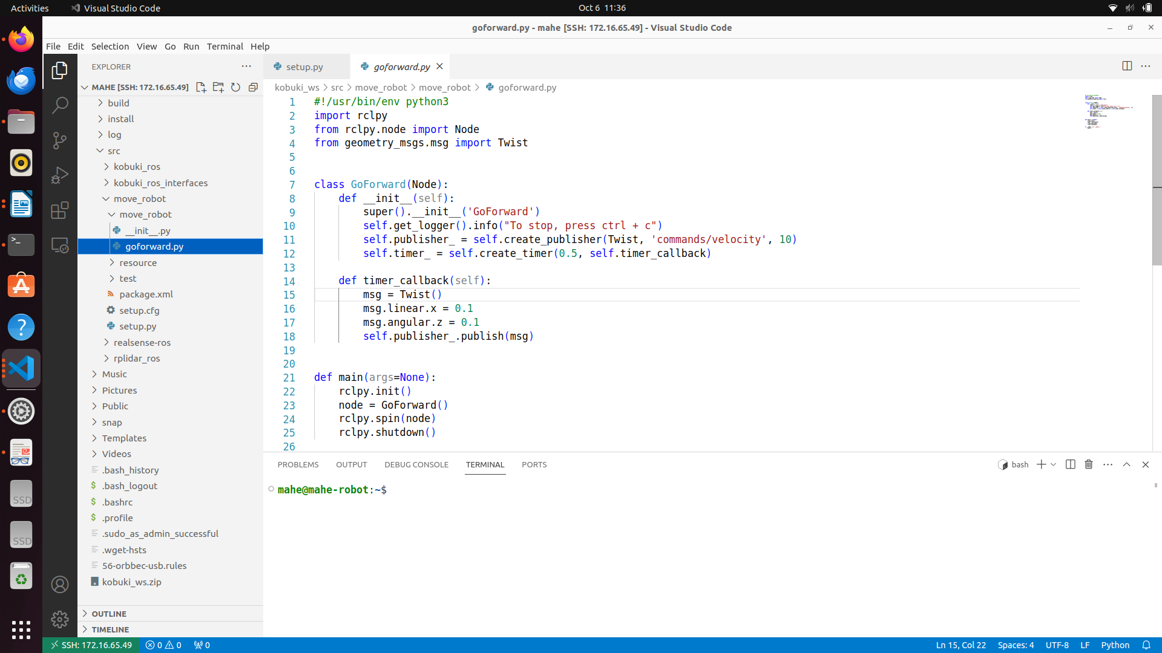

cd ~/kobuki_ws
colcon build
Terminal 1
ros2 launch kobuki_node kobuki_node-launch.py
Terminal 2 (split the terminal)
ros2 run turtlebot_pkg goforward

Program 2:
Generate a square path using turtebot

#!/usr/bin/env python3

import rclpy
from rclpy.node import Node
from geometry_msgs.msg import Twist
import math
import time

class DrawSquare(Node):
def __init__(self):
super().__init__('draw_square')
self.get_logger().info("Drawing Square")
self.publisher_ = self.create_publisher(Twist, 'commands/velocity', 10)
#self.timer_ = self.create_timer(0.5, self.timer_callback)
move_vel = Twist()
move_vel.linear.x = 0.2

turn_vel = Twist()
turn_vel.linear.x = 0.0
turn_vel.angular.z = math.radians(45)
count = 0
while(True):
self.get_logger().info("Going Straiggt")
for x in range(0,10):
self.publisher_.publish(move_vel)
time.sleep(0.5)
self.get_logger().info("Turning")
for x in range(0,5):
self.publisher_.publish(turn_vel)
time.sleep(0.5)
count = count+1
if (count == 4):
count = 0

def main(args=None):
rclpy.init()
node = DrawSquare()
rclpy.spin(node)
rclpy.shutdown()

if __name__ == '__main__':
main()

from setuptools import setup

package_name = 'turtlebot_pkg'

setup(
name=package_name,
version='0.0.0',
packages=[package_name],
data_files=[
('share/ament_index/resource_index/packages',
['resource/' + package_name]),
('share/' + package_name, ['package.xml']),
],
install_requires=['setuptools'],
zip_safe=True,
maintainer='robolab',
maintainer_email='robolab@todo.todo',
description='TODO: Package description',
license='TODO: License declaration',
tests_require=['pytest'],
entry_points={
'console_scripts': [
'goforward = turtlebot_pkg.goforward:main',
'square = turtlebot_pkg.draw_square:main'
],
},
)

Check the battery status of the turtlebot

#!/usr/bin/env python3

import rclpy
from sensor_msgs.msg import BatteryState
from rclpy.node import Node

class BatteryStatus(Node):
def __init__(self):
super().__init__('battery_status')
self.subscriber_ = self.create_subscription(BatteryState,'sensors/battery_state',self.status_callback, 10)

def status_callback(self,msg):
self.get_logger().info("Current Battery Status of the Turtlebot is " + str(msg.percentage))

def main(args=None):
rclpy.init()
node = BatteryStatus()
rclpy.spin(node)
rclpy.shutdown()

if __name__ == '__main__':
main()

from setuptools import setup

package_name = 'turtlebot_pkg'

setup(
name=package_name,
version='0.0.0',
packages=[package_name],
data_files=[
('share/ament_index/resource_index/packages',
['resource/' + package_name]),
('share/' + package_name, ['package.xml']),
],
install_requires=['setuptools'],
zip_safe=True,
maintainer='robolab',
maintainer_email='robolab@todo.todo',
description='TODO: Package description',
license='TODO: License declaration',
tests_require=['pytest'],
entry_points={
'console_scripts': [
'goforward = turtlebot_pkg.goforward:main',
'square = turtlebot_pkg.draw_square:main',
'battery = turtlebot_pkg.battery_status:main'
],
},
)

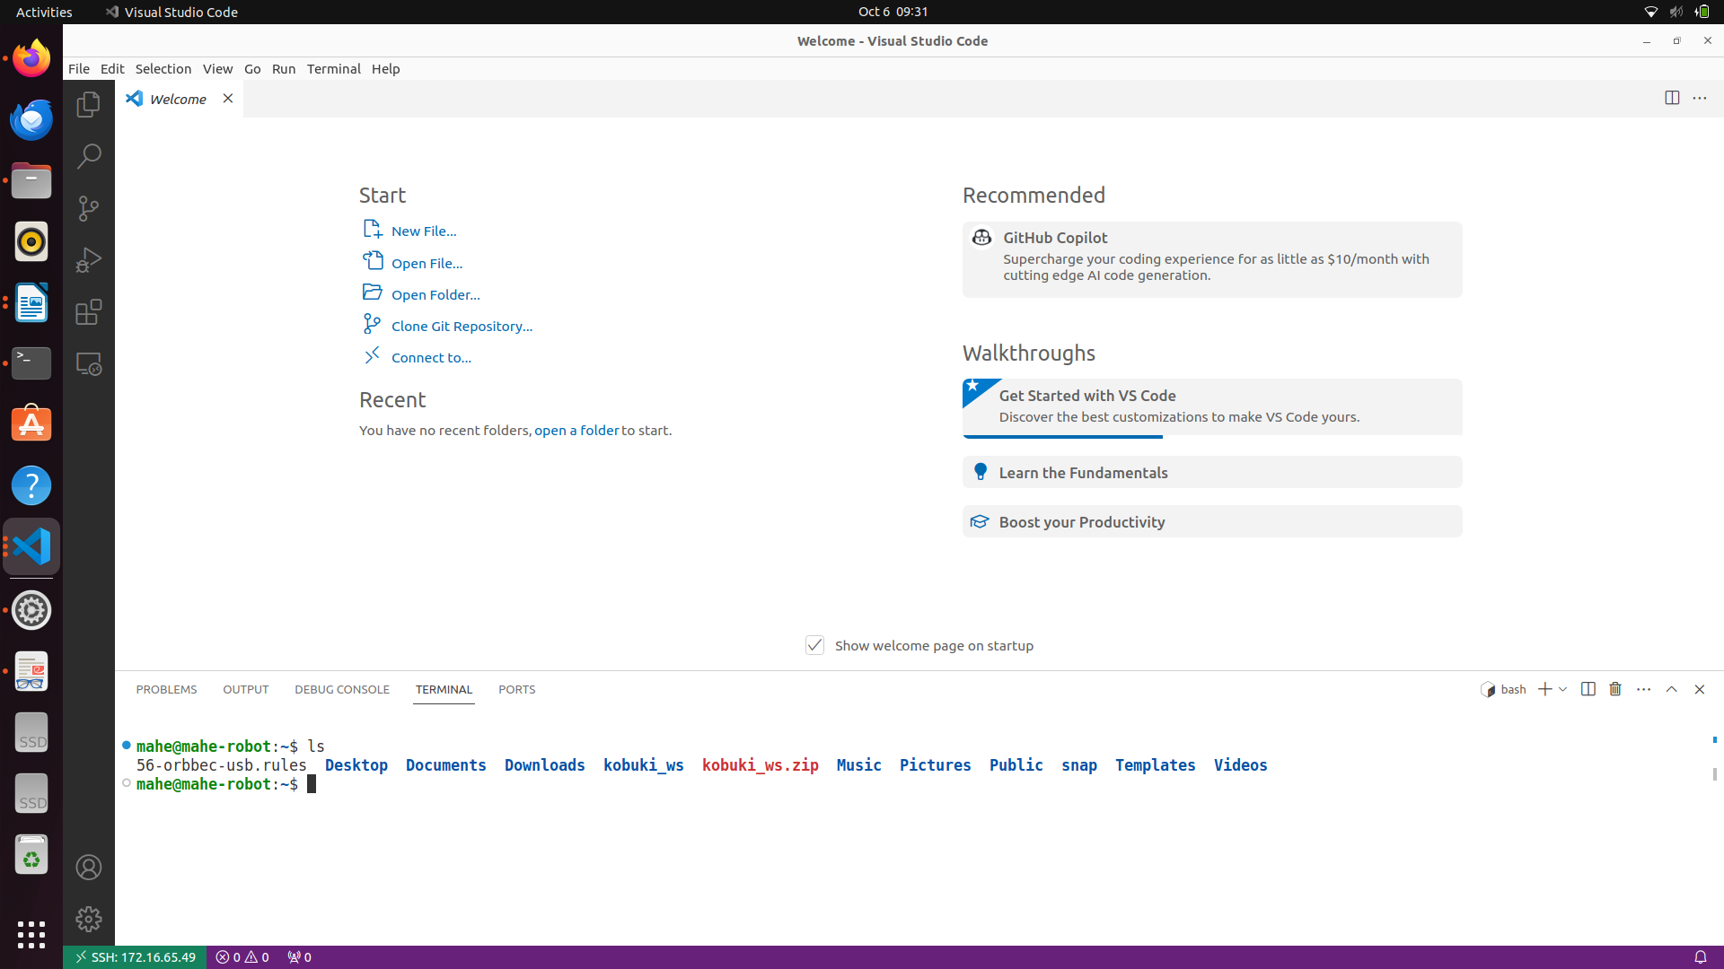

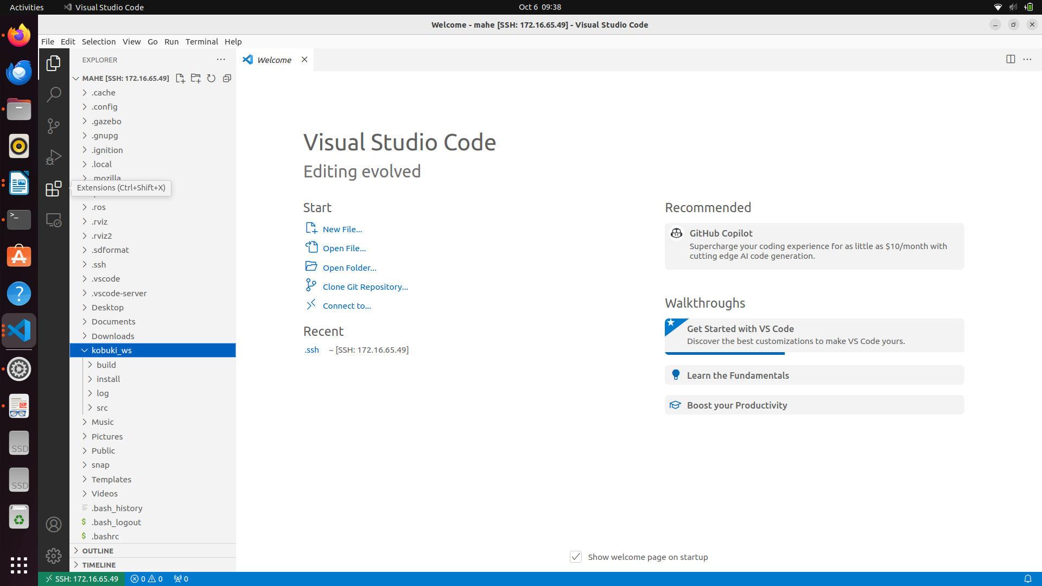

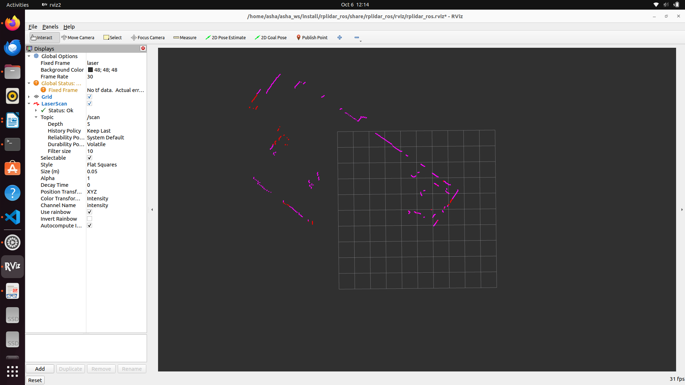
Lidar interfacing

Depth camera interfacing

